“Kyiv Professional College of Communications”

Computer Engineering Cycle Commission

**PERFORMANCE REPORT**

**LABORATORY WORK №3**

in the discipline: "Operating Systems"

**Topic: "Basic Linux commands for working with files and directories"**

Performed by students

RPZ-93B group

Team:

Бушовська О.В,

Білобровенко О.С.,

Скворцов Д.Є.

The teacher checked:

Сушанова В.С.

Київ 2022

**The goal of the work:**

1. Gaining practical skills in working with the Bash shell.

2. Familiarity with the basic actions when working with help.

3. Familiarity with basic actions when working with files and directories..

**Material support of classes**

1. Computer type IBM PC.

2. Windows family of operating systems (Windows 7).

3. Virtual machine - Virtual Box (Oracle).

4. GNU / Linux operating system - CentOS.

5. Cisco Network Academy website netacad.com and its online Linux courses

**Tasks for preliminary preparation.**

***Готувала матеріал студентка Бушовська Ольга***

1.Read brief theoretical information for laboratory work and make a small dictionary basic English terms for assigning teams and their parameters.

|  |  |
| --- | --- |
| Англійська | Українська |
| directory structure | Структура |
| root | корінь |
| forward slash | Косою рискою |
| backward slash | Зворотна коса смуга |

***Готувала матеріал студентка Білобровенко Олександра***

2. On the basis of the considered material give answers to the following questions:

2.1. What is the directory structure of a Unix-like file system? What is the purpose of basic directories?

Files in UNIX-like operating systems are stored in a tree-like hierarchical file system. The root of the file system is the root directory, which is denoted by the symbol "/". Each intermediate node in the file system tree is a directory. The end vertices of the file system tree are empty directories or files. The absolute path file name consists of the names of all directories leading to the specified file, starting with the root directory. Thus, the path name "/ etc / passwd" means that the file "passwd" is located in the directory "etc", which, in turn, is in the root directory "/".

Recall that directories are the files from which the hierarchical structure of the file system is built; they play an important role in converting the file name to the index node number. The directory, like a regular file, is described by an index node. A directory is a file that contains a set of records, the most important fields of which are the index number d_ino and the name of the file d_name included in the directory. A compound name is a string of characters that ends with an empty character and is separated by a slash "/" into several components. Each component, except the last, must be a directory name, but the last component can be a non-directory file name. In the ext2 file system of Linux, the length of each component of the file name is limited to 255 characters.

2.2. Explain the concept of FHS. How is this standard used in the context of file systems?

The file system hierarchy of UNIX-like systems follows a single standard called FHS (Filesystem Hierarchy Standard). The idea of ​​this standard is that all OS files and directories should have a specific location (which, in principle, is reasonable). FHS allows users and software to be confident in the location of files and directories.

Filesystem Hierarchy Standard, FHS is a standard adopted to unify the location of general-purpose files and directories in the UNIX file system. Today, most UNIX-like systems follow these rules to some degree. For example, the default user database is always stored in the / etc / passwd file.

In FHS, all files and directories are inside the root directory, even if they are located on different physical or virtual media. However, some directories may only be present if certain software, such as the X Window System, is installed. Most of these directories exist on all UNIX-like operating systems and are used in a similar way.

2.3. Define the mounting process. What is the approach to its use in Linux. Hover

examples.

File system mounting is a system process that prepares a disk partition for use by the operating system.

The mounting operation consists of several stages:

1. Determining the type of file system to be mounted.

2. Check the integrity of the mounted file system.

3. Reading system data structures and initializing the corresponding module of the file manager (file system driver).

4. Set the flag that notifies the end of the installation. If the file system is dismantled correctly, this check box is cleared. If the system determines during boot that the check box is not cleared, then the work was completed incorrectly, and the file system may need to be repaired.

5. Include a new file system in the shared namespace.

Mounting in Linux allows you to access the contents of the disk and organize the structure of the file system. You can also use mount to open a disk image (for example, created with dd), as well as open and edit various file systems and disk images (for example, virtual machine disk images); even remote network directories can be mounted, making them available as files in any other local storage.

In Linux, there is such a thing as "mounting" a disk. To access the files on this drive, you must first mount it. Mounting is the most powerful thing, which allows you to surprisingly flexibly configure the file system!

The point of mounting is that a new directory (normal folder) is created in the file system, let's say it's the / mnt / disk_d folder. The mount command then indicates that, for example, the / dev / sda drive is now mounted in the / mnt / disk_d directory. You can then access the / dev / sda disk files by opening the / mnt / disk_d folder in any file manager.

2.4. List the basic commands for working with files and directories in Linux: create, move, copy, view content, delete.

Files are created using the command:

touch name_ files

Directories are created using a command like:

mkdir name_ directories

The mv command is used to move and rename files and directories . The name of this command is an abbreviation for the word move.

You can rename a file with the command:

mv name_ files new_name

To move a file, use the command:

mv name_ files path /

The cp command is used for copying . The name of this command is an abbreviation for the word copy.

To copy the file file1 and name it file2, use the command:

cp file1 file2

To copy the dir1 directory to the dir2 directory, use the command:

cp -a dir1/ dir2/

You can copy a file named file1 to a directory named dir1 using the command:

cp file1 dir1/

The ls command is used to list the contents of a directory . The name of this command is short for list files.

You can view the contents of any directory in the following ways:

ls name_ directories

Or by entering the command:

ls / path _to _directory

The rm command is used to remove files . For example, to delete a file named file1, use the command:

rm file1

The rm command also allows you to delete not only files, but also directories.

To remove a directory named dir1 with all subdirectories and files, use the -r option (from the word recursive):

rm -r dir1

3. Study Cisco Academy Online Course Materials:

- NDG Linux Unhatched (Chapter 7, 10, 11, and 13 all Topics)

- NDG Linux Essentials (Chapter 6, 7 and 8 all Topics)

4. Take the NDG Linux Essentials course on the following topics:

- Chapter 06 Exam

- Chapter 07 Exam

- Chapter 08 Exam

5. Prepare in electronic form the initial version of the report:

- Title page, topic and purpose of the work

- Glossary of terms

- Answers to item 2.1 and item 2.4 of the tasks for preliminary training

Progress.

1. Initial work in CLI mode in Linux Linux family:

1.1. Start the VirtualBox virtual machine, select CentOS, and start it. Log in

under the user: CentOS, password for login: reverse (if you perform LR in 401 aud.) and lower

terminal.

1.2. Start the Ubuntu_PC virtual machine (if you are performing LR tasks through the netacad academy)

1.3. Start your Linux operating system (if you are running on your own PC and

installed) and start the terminal.

2. Study all the examples of commands presented in the laboratory work of the NDG Linux course

Essentials:

- Lab 6: Getting Help

- Lab 7: Navigating the Filesystem

- Lab 8: Managing Files and Directories

***Готувала матеріал студентка Бушовська Ольга***

3. Create a table of commands studied in paragraph 2 of the course of work as follows:

|  |  |
| --- | --- |
| Назва команди | Її призначення та функціональність |
| / | root of the virtual directory, where normally, no files are placed |
| /bin | binary directory, where many GNU user-level utilities are stored |
| /boot | boot directory, where boot files are stored |
| /dev | device directory, where Linux creates device nodes |
| /etc | system configuration files directory |
| /home | home directory, where Linux creates user directories |
| /lib | library directory, where system and application library files are stored |
| /media | media directory, a common place for mount points used for removable media |
| /mnt | mount directory, another common place for mount points used for removable media |
| /opt | optional directory, often used to store third-party software packages and data files |
| /proc | process directory, where current hardware and process information is stored |
| /root | root home directory |
| /sbin | system binary directory, where many GNU admin-level utilities are stored |
| /run | run directory, where runtime data is held during system operation |
| /srv | service directory, where local services store their files |
| /sys | system directory, where system hardware information files are stored |
| /tmp | temporary directory, where temporary work files can be created and destroyed |
| /usr | user binary directory, where the bulk of GNU user-level utilities and data files are stored |
| /var | variable directory, for files that change frequently, such as log files |

4. Start the terminal, and on the command line, follow these steps to learn how to work with

catalogs:

- You must get the name of the current directory;

- You need to go to the root directory and view its contents in different formats

(use different keys of the ls command);

- You need to go back and view the contents of the current user's home directory

(perform this action through the pipeline of commands);

- In the current directory, create a directory with the name of your group;

***Готувала матеріал студентка Бушовська Ольга***

- View the updated contents of the current user's home directory. Take advantage

with the -F –color keys of the ls command, what information will you get?

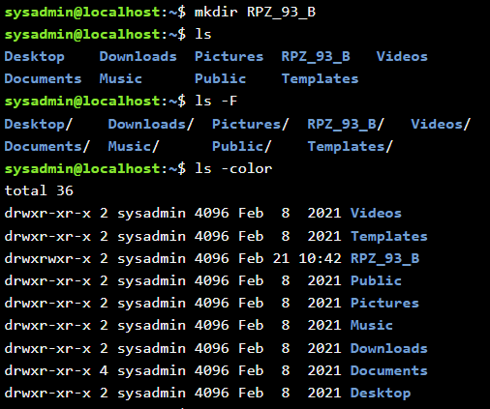

- Create a subdirectory in the directory with the name of your group with the name of your last name (first name,

login, etc.);



- View the contents of the home directory and its subdirectories using a recursive key

view -R (ls command), what additional information will it give?

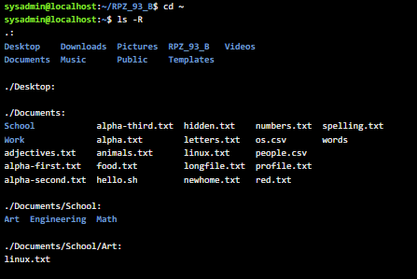

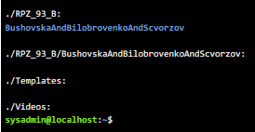

Test questions

1. List the main features of the cat command, give examples with explanations.

2. How can I add information to a file in the terminal? What will be the difference if necessary will not add, but rewrite its contents?

***Готувала матеріал студентка Білобровенко Олександра***

3. How to copy and delete an existing directory? Will there be a difference in commands if the directory is not empty at the same time.

cp - r dir1 dir2 - copy directory dir1 to dir2;

rm - r dir - delete directory dir;

rm command

The previous tool is one of the components of the rm utility. Initially, it is intended for deleting files, but if you give it the appropriate argument, it will erase the folder. This option is already suitable for non-empty directories, in the console you need to enter rm -R folder (or the full path to the directory). Note the -R argument - it triggers recursive deletion, ie it applies to the entire contents of the folder and itself. The case must be taken into account when entering, because -r is a completely different option.

rmdir command

First of all I would like to touch rmdir. It is designed to clean the system only from empty directories. Removes them permanently, and the advantage of this tool is the simplicity of its syntax and the absence of any errors. In the console it is enough to register rmdir folder, where folder is the name of the folder in the current location. The tool is activated by pressing the Enter key.

For empty rmdir, for non-empty rm.

4. In which of the following examples is the file moving? rename it?

both actions at the same time?

- mv /work/tech/comp.png. / Desktop moving

- mv /work/tech/comp.png. /work/tech/my_car.png rename

- mv /work/tech/comp.png. /Desktop/computer.png both actions at the same time

**Conclusion:** I gained practical skills in working with the Bash shell, learned the basics of working with help, and learned the basics of working with files and directories, and learned Cisco Academy online courses.